

# CS2201- APPLICATION DEVELOPMENT PRACTICES

(Regulation 2022)

Project Report

## Name of the Student : PRIYA.D

Register Number :22AD088

## Year / Semester / Section :Ist YEAR/IInd/”B”-SECTION

Branch :AI&DS

## Project Title : TOUR &TRAVEL WEBAGE



**Register No:**

|  |  |  |  |  |  |  |  |  |  |  |  |
| --- | --- | --- | --- | --- | --- | --- | --- | --- | --- | --- | --- |
| 2 | 2 | A | D | 0 | 8 | 8 |  |  |  |  |  |

**BONAFIDE CERTIFICATE**

This is to certify that the work entitled

**TOUR&TRAVEL WEBPAGE** bonafide project done by Mr./**Ms.PRIYA** of II semester **B.tech AI&DS** in the Application Development Practices -CS2201 during the academic year 2022 - 2023

**Staff – in – Charge Head of the Department**

***DESCRIPTION***

Tour and Travel Website Project using HTML, CSS, and JavaScript. In this academic project, we are going to create an Tour and Travel Website using basic HTML, CSS, and JavaScript. We have planned and going to create as per the design given by the instructor. Which include

A home page that will provide all the necessary views. And it includes the link to the various linked pages (login, booking)

The top bars include the link to every single linked page.

My Login page contains: Username(Email id), Password.

My signup page contains: Name, Email id, Password, Phone no.

***Concept:***

We have used the concept of HTML Programming like a Hyperlink projection. Use of different tags to make it visually better like font, table, listing, hyperlink, styling,

Use of:

* **Button**
* **Navigation bar**
* **Contanier**
* **Grid**
* **Footer**
* **Header**

All designing and programming are done by us only.

***PROJECT DESCRIPTION***

Project Name: Tour and Travel Website

Languages Used: HTML, CSS, JavaScript

Software Used: Sublime Text

Browser Used: Microsoft edge

***DESCRIPTION:***

This project is not a pure website that works on the internet. This project is just a template of a bank website, which can be used with the backend to create a perfectly working website. This website is work fine with **JavaScript**, **CSS** (*Cascading Style* *Sheet*), and **HTML** (*Hyper Text Markup* *Language*), with some simple concepts to make it a Responsive Web Page.

***PROJECT CONTENT:***

This website is consist of various HTML pages, which are linked to each other with links (either by link or anchor tag).

Following are the HTML file names involved in the project:

* Index
* Login
* Home
* About
* Destination
* Services
* Gallery
* Blogs

Following are the CSS files name involved in this project: (Here, we used a simple convention in the naming of the files: “html filname.css”)

* Index
* Login
* Home
* About
* Destination
* Services
* Gallery
* Blogs

Following are the JavaScript file names involved in this project:

* Login page and all page.

***CONCEPTS USED***

As above mentioned, this template website is made up of HTML, CSS, and JavaScript.

***The concept used in HTML:***

Using the link to add an external CSS file to it.

Using the “src” attribute with the “script” tag we link external JavaScript.

Using the “div” tag to separate various parts of the webpage to give functionality and style separately.

Using “h1” tags to give a heading.

Using “img” tag to give images on the webpage.

Using anchor (“a”) tags to link multiple HTML files to each other.

Using “id” and “class” attributes with different tags to give them style and functionality accordingly.

Using the “form” tag to use the form for the login and sign-up page.

Using the “method” attribute’s value as “POST” to give the

form data securely.

Using “input” tags to make an input field for the users. (With its different types.)

Using “onload”, “onclick”, “onblur”, “onchange” with its value to call the functions which are in the respective JavaScript files on loading the webpage, on clicking a

button, on losing focus, and changing the state respectively.

Using “label” tags to create labels for the input fields.

Using “select” tags to create a drop-down menu or combo box in the form.

Using “option” tags inside the “select” tag to give options in the drop-down menu.

Using “button” tags to create a button for submitting and resetting the form.

***The concept used in CSS:***

Using “#” and “.” to access elements with their id and class values respectively.

Using some pseudo-classes to make a somewhat interactive web page. (Without using JS.)

Using media queries to make the page responsive for some specific display ratios.

Using “@import” for importing another CSS file to a specific file.

***The concept used in Javascript:***

Using Regular Expression (RegEx) for creating a pattern for email and password validations as they have a specific pattern in them.

Using “window.location.replace()” to go to a specific location on calling it.

And using other pre-defined functions to create our user-defined functions.

***CONCLUSION***

This Tour and Travel website project is completed in two scripting languages i.e. HTML and CSS,

and JavaScript.

***REFERENCES***

1.w3school.org

2.geeeksofgeeks.com

***SOURCE CODE:***

***HTML***

<!DOCTYPE html>

<html lang="en">

<head>

<meta charset="UTF-8">

<meta http-equiv="X-UA-Compatible" content="IE=edge">

<meta name="viewport" content="width=device-width, initial-scale=1.0">

<title>TRIP</title>

<link rel="stylesheet" href="https://cdnjs.cloudflare.com/ajax/libs/font-awesome/5.15.4/css/all.min.css">

<link rel="stylesheet" href="css/style.css">

<link rel="stylesheet" href="https://cdnjs.cloudflare.com/ajax/libs/aos/2.3.4/aos.css">

<script src="js/script.js" defer></script>

</head>

<body>

<header class="header">

<div id="menu-btn" class="fas fa-bars"></div>

<a data-aos="zoom-in-left" data-aos-delay="150" href="#" class="logo"> <i class="fas fa-paper-plane"></i>TRAVEL</a>

<nav class="navbar">

<a data-aos="zoom-in-left" data-aos-delay="300" href="#home">home</a>

<a data-aos="zoom-in-left" data-aos-delay="450" href="#about">about</a>

<a data-aos="zoom-in-left" data-aos-delay="600"

href="#destination">destination</a>

<a data-aos="zoom-in-left" data-aos-delay="750" href="#services">services</a>

<a data-aos="zoom-in-left" data-aos-delay="900" href="#gallery">gallery</a>

<a data-aos="zoom-in-left" data-aos-delay="1150" href="#blogs">blogs</a>

</nav>

<a data-aos="zoom-in-left" data-aos-delay="1300" href="#book-form" class="btn">book now</a>

<a data-aos="zoom-in-left" data-aos-delay="1300" href="login.html" class="btn">login</a>

</header>

<section class="home" id="home">

<div class="content">

<span data-aos="fade-up" data-aos-delay="150">follow us</span>

<h3 data-aos="fade-up" data-aos-delay="300">to travel</h3>

<p data-aos="fade-up" data-aos-delay="450">India, therefore, has a lot of potential for tourism. India offers a variety of sights to see and things to do. The Himalayan ranges border it in the north and the Arabian Sea, Bay of Bengal, and the Indian Ocean on three sides. India is beautiful because of its picturesque backwaters, hill towns, and landscapes.</p>

<a data-aos="fade-up" data-aos-delay="600" href="login.html" class="btn">login </a>

</div>

</section>

<section class="book-form" id="book-form">

<form action="">

<div data-aos="zoom-in" data-aos-delay="150" class="inputBox">

<span>where to?</span>

<input type="text" placeholder="place name" value="">

</div>

<div data-aos="zoom-in" data-aos-delay="300" class="inputBox">

<span>when?</span>

<input type="date" value="">

</div>

<div data-aos="zoom-in" data-aos-delay="450" class="inputBox">

<span>how many?</span>

<input type="number" placeholder="number of travelers" value="">

</div>

<input data-aos="zoom-in" data-aos-delay="600" type="submit" value="find now" class="btn">

</form>

</section>

<section class="about" id="about">

<div class="video-container" data-aos="fade-right" data-aos-delay="300">

<video src="images/video-1.mp4" muted autoplay loop class="video"></video>

<div class="controls">

<span class="control-btn" data-src="video-1.mp4"></span>

<span class="control-btn" data-src="video-2.mp4"></span>

<span class="control-btn" data-src="video-3.mp4"></span>

</div>

</div>

<div class="content" data-aos="fade-left" data-aos-delay="600">

<span>why choose us?</span>

<h3>Nature's Majesty Awaits You</h3>

<p>India is a country that attracts millions of tourists every year and is considered one of the most popular tourist destinations in the world</p>

</section>

<section class="destination" id="destination"><

div class="heading">

<span>our destination</span>

<h1>make yours destination</h1>

</div>

<div class="box-container">

<div class="box" data-aos="fade-up" data-aos-delay="150">

<div class="image">

<img src="image-1.jpg" alt="">

</div>

<div class="content">

<h3>taj mahal,agra</h3>

<p>Agra is home to several historic monuments, making it one of the most visited places in India. Of course, top of this list of places to see in Agra is the Taj Mahal, one of the most famous buildings in the world.</p>

<a href="#">read more <i class="fas fa-angle-right"></i></a>

</div>

</div>

<div class="box" data-aos="fade-up" data-aos-delay="300">

<div class="image">

<img src="image-2.jpg" alt="">

</div>

<div class="content">

<h3>red fort,delhi</h3>

<p>New Delhi, the national capital of India, is one of the most cliched yet popular tourist destinations in the country. The state has so much to offer that visiting it once or twice is not enough. Delhi is dotted with iconic Mughal monuments, temples, heritage sites, performing arts venues, colourful bazaars, shopping malls, planetariums, museums, and restaurants, so there is something for everyone here. Chandni Chowk, the oldest and busiest market in the country, is in Delhi.</p>

<a href="#">read more <i class="fas fa-angle-right"></i></a>

</div>

</div>

<div class="box" data-aos="fade-up" data-aos-delay="450">

<div class="image">

<img src="image-3.jpg" alt="">

</div>

<div class="content">

<h3>lonavala and khandala,mumbai</h3>

<p>Perched at a height of 622 metres above sea level, Lonavala and Khandala are twin hill stations in the state of Maharashtra. Thanks to their pleasant weather conditions and proximity to Mumbai and Pune, the hill stations are frequented by

Mumbaikars and Punekars year-round. Both Lonavala and Khandala come to life during the monsoon season when lush greenery, sparkling lakes and milky-white waterfalls add to the beauty of the landscape.</p>

<a href="#">read more <i class="fas fa-angle-right"></i></a>

</div>

</div>

<div class="box" data-aos="fade-up" data-aos-delay="600">

<div class="image">

<img src="image-4.jpg" alt="">

</div>

<div class="content">

<h3>mysore palace,bangalore</h3>

<p>In the southern tip of India, you’ll find the city of Mysore. Once the capital of the Wodeyar dynasty, Mysore is best known for housing the magnificent Mysore Palace. The palace is the epitome of opulence, and a tour through the structure will reveal upscale touches like carved rosewood doors, ceilings decorated in ivory and countless paintings on the walls.</p>

<a href="#">read more <i class="fas fa-angle-right"></i></a>

</div>

</div>

<div class="box" data-aos="fade-up" data-aos-delay="750">

<div class="image">

<img src="image-5.jpg" alt="">

</div>

<div class="content">

<h3>thanjai periya kovil,tamilnadu</h3>

<p>The Tanjore Big Temple is a stunning monument built by Raja Raja Cholan, greatest king of Chola Dynasty. It was constructed between the year AD 985 and 1014, completed around 1010 AD. The temple is popularly known as the Big Temple, Rajarajesvaram Temple or Peruvudaiyār Kōvil temple.</p>

<a href="#">read more <i class="fas fa-angle-right"></i></a>

</div>

</div>

<div class="box" data-aos="fade-up" data-aos-delay="900">

<div class="image">

<img src="image-6.jpg" alt="">

</div>

<div class="content">

<h3>munnar,kerala</h3>

<p>Nestled in the Western Ghats in the state of Kerala, Munnar is counted among the most serene and beautiful places to visit in India. The hill station boasts impeccable natural beauty in the form of rolling hills, scenic valleys, virgin forests, waterfalls, streams, national parks, tea and spice plantations and winding walkways. However, it is the unmissable colonial charm of Munnar that attracts many tourists time and again.</p>

<a href="#">read more <i class="fas fa-angle-right"></i></a>

</div>

</div>

<div class="box" data-aos="fade-up" data-aos-delay="1150">

<div class="image">

<img src="image-9.jpg" alt="">

</div>

<div class="content">

<h3>manali,himachal pradesh</h3>

<p>Situated in the Kullu Valley of Himachal Pradesh, Manali draws tourists with its natural beauty and tranquillity. The hill station is frequented by travellers from across the country, especially during the summer season when cities reel under the scorching heat. Snow-capped

mountains, dense forests, riverine valleys and sparkling streams add to the beauty of the hill station and make it one of the most popular holiday destinations in India.</p>

<a href="#">read more <i class="fas fa-angle-right"></i></a>

</div>

</div>

<div class="box" data-aos="fade-up" data-aos-delay="1300">

<div class="image">

<img src="image-8.jpg" alt="">

</div>

<div class="content">

<h3>goa</h3>

<p>Famous for its pristine beaches, hippie vibes, laidback lifestyle and vibrant parties, Goa is counted among the best holiday destinations in India. The union territory is frequented by tourists year-round, especially in the winter season when the climate is pleasant, and the entire place comes alive with Christmas and New Year celebrations. However, seasoned tourists do not shun Goa during summer either</p>

<a href="#">read more <i class="fas fa-angle-right"></i></a>

</div>

</div>

</div>

</section>

<section class="services" id="services">

<div class="heading">

<span>our services</span>

<h1>countless expericences</h1>

</div>

<div class="box-container">

<div class="box" data-aos="zoom-in-up" data-aos-delay="150">

<i class="fas fa-globe"></i>

<h3>worldwide</h3>

<p>India will teach us the tolerance and gentleness of mature mind, understanding spirit and a unifying, pacifying love for all human beings.</p>

</div><div class="box" data-aos="zoom-in-up" data-aos-delay="300">

<i class="fas fa-hiking"></i>

<h3>adventures</h3>

<p> The greatest adventure is what lies ahead.</p>

</div>

<div class="box" data-aos="zoom-in-up" data-aos-delay="450">

<i class="fas fa-utensils"></i>

<h3>food & drinks</h3>

<p>Staple foods of Indian cuisine include pearl millet (bājra), rice, whole-wheat flour (aṭṭa), and a variety of lentils, such as masoor (most often red lentils), tuer (pigeon peas), urad (black gram), and moong (mung beans). Lentils may be used whole, dehusked—for example, dhuli moong or dhuli urad—or split..</p></div>

<div class="box" data-aos="zoom-in-up" data-aos-delay="600">

<i class="fas fa-hotel"></i>

<h3>affordable hotels</h3>

<p>The primary purpose of hotels is to provide travelers with shelter, food, refreshment, and similar services and goods, offering on a commercial basis things that are customarily furnished within households but unavailable to people on a journey away from home.</p>

</div>

<div class="box" data-aos="zoom-in-up" data-aos-delay="750">

<i class="fas fa-wallet"></i>

<h3>affordable price</h3>

<p>A vacation is something we all desire for, mostly to break the monotony of life. Whether the escape is for a day or a few days, we try to engage in stress-busting activities that eventually delight us to a certain extent.

.</p>

</div>

<div class="box" data-aos="zoom-in-up" data-aos-delay="900">

<i class="fas fa-headset"></i>

<h3>24/7 support</h3>

<p>Dell Customer Care No. 1800 425 2067</p>

</div>

</div>

</section> <section class="gallery" id="gallery">

<div class="heading">

<span>our gallery</span>

<h1>we record memories</h1>

</div>

<div class="box-container">

<div class="box" data-aos="zoom-in-up" data-aos-delay="150">

<img src="travel-1.jpg" alt="">

<span>travel spot</span>

<h3>varanasi</h3>

</div>

<div class="box" data-aos="zoom-in-up" data-aos-delay="300">

<img src="travel-2.jpg" alt="">

<span>travel spot</span>

<h3>coorg</h3>

</div>

<div class="box" data-aos="zoom-in-up" data-aos-delay="450">

<img src="travel-3.jpg" alt="">

<span>travel spot</span>

<h3>andaman</h3>

</div>

<div class="box" data-aos="zoom-in-up" data-aos-delay="150">

<img src="travel-4.jpg" alt="">

<span>travel spot</span>

<h3>alleppey</h3>

</div>

<div class="box" data-aos="zoom-in-up" data-aos-delay="300">

<img src="travel-5.jpg" alt="">

<span>travel spot</span>

<h3>marina beach</h3>

</div>

<div class="box" data-aos="zoom-in-up" data-aos-delay="450">

<img src="travel-6.jpg" alt="">

<span>travel spot</span>

<h3>darjaling</h3>

</div>

<div class="box" data-aos="zoom-in-up" data-aos-delay="150">

<img src="travel-7.jpg" alt="">

<span>travel spot</span>

<h3>kodaikanal</h3>

</div>

<div class="box" data-aos="zoom-in-up" data-aos-delay="300">

<img src="travel-8.jpg" alt="">

<span>travel spot</span>

<h3>amristsar</h3>

</div>

<div class="box" data-aos="zoom-in-up" data-aos-delay="450">

<img src="travel-9.jpg" alt="">

<span>travel spot</span>

<h3>hyderabad</h3>

</div>

</div>

</section>

<section class="review">

<div class="content" data-aos="fade-right" data-aos-delay="300">

<span>testimonials</span>

<h3>good news from our clients</h3>

<p>India, therefore, has a lot of potential for tourism. India offers a variety of sights to see and things to do. The Himalayan ranges border it in the north and the Arabian Sea, Bay of Bengal, and the Indian Ocean on three sides. India is beautiful because of its picturesque backwaters, hill towns, and landscapes.</p>

</div>

<div class="box-container" data-aos="fade-left" data-aos-delay="600">

<div class="box"><p>Tourism in India is important for the country's economy and is growing rapidly.</p>

<div class="user">

<img src="pic-1.png" alt="">

<div class="info">

<h3>abdul</h3>

<span>designer</span>

</div>

</div>

</div>

<div class="box">

<p>India is one of Asia's most popular tourist destinations.</p>

<div class="user">

<img src="pic-2.png" alt="">

<div class="info">

<h3>lily</h3>

<span>designer</span>

</div>

</div>

</div>

<div class="box">

<p>India is a country that attracts millions of tourists every year and is considered one of the most popular tourist destinations in the world</p>

<div class="user">

<img src="pic-3.png" alt="">

<div class="info">

<h3>kumar</h3>

<span>designer</span>

</div>

</div>

</div>

<div class="box">

<p> Indian tourism is a very productive activity both for the tourist and the government</p>

<div class="user">

<img src="pic-4.png" alt="">

<div class="info">

<h3>rose</h3>

<span>designer</span>

</div>

</div>

</div>

</div>

</section>

<section class="blogs" id="blogs">

<div class="heading">

<span>blogs & posts</span>

<h1>we untold stories</h1>

</div>

<div class="box-container">

<div class="box" data-aos="fade-up" data-aos-delay="150">

<div class="image">

<img src="story-1.jpg" alt="">

</div>

<div class="content">

<a href="#" class="link">Life is a journey, not a destination</a>

<p>South India Tourism is globally known for the exotic tourist spots in the states of Tamil Nadu, Kerela, Karnakata, Andhra Pradesh, and Pondicherry. Tamil Nadu Tourism has developed a lot in the fast few years. </p>

<div class="icon">

<a href="#"><i class="fas fa-clock"></i> 1st may, 2023</a>

<a href="#"><i class="fas fa-user"></i> by admin</a>

</div>

</div>

</div>

<div class="box" data-aos="fade-up" data-aos-delay="300">

<div class="image">

<img src="story-2.jpg" alt="">

</div>

<div class="content">

<a href="#" class="link">Life is a journey, not a destination</a>

<p>North India is a loosely defined region consisting of the northern part of India. The dominant geographical features of North India are the Indo-Gangetic Plain and the Himalayas, which demarcate the region from the Tibetan Plateau and Central Asia.</p>

<div class="icon">

<a href="#"><i class="fas fa-clock"></i> 1st may, 2023</a>

<a href="#"><i class="fas fa-user"></i> by admin</a>

</div>

</div>

</div>

<div class="box" data-aos="fade-up" data-aos-delay="450">

<div class="image">

<img src="story-3.jpg" alt="">

</div>

<div class="content">

<a href="#" class="link">Life is a journey, not a destination</a>

<p>Northeast of India is home to many wildlife sanctuaries like Kaziranga National Park famous for the one horned rhinoceros, Manas National Park, Nameri, Orang, Dibru Saikhowa in Assam, Namdhapha in Arunachal Pradesh, Balpakram in Meghalaya,</p>

<div class="icon">

<a href="#"><i class="fas fa-clock"></i> 1st may, 2023</a>

<a href="#"><i class="fas fa-user"></i> by admin</a>

</div>

</div>

</div>

</div>

</section>

<div class="banner">

<div class="content" data-aos="zoom-in-up" data-aos-delay="300">

<span>start your adventures</span>

<h3>Let's Explore This World</h3>

<p>India, therefore, has a lot of potential for tourism. India offers a variety of sights to see and things to do. The Himalayan ranges border it in the north and the Arabian Sea, Bay of Bengal, and the Indian Ocean on three sides. India is beautiful because of its picturesque backwaters, hill towns, and landscapes.</p>

<a href="#book-form" class="btn">book now</a>

</div>

</div>

<section class="footer">

<div class="box-container">

<div class="box" data-aos="fade-up" data-aos-delay="150">

<a href="#" class="logo"> <i class="fas fa-paper-plane"></i>travel </a>

<p>Tourism in India is important for the country's economy and is growing rapidly</p>

<div class="share">

<a href="http://www.facebook.com" class="fab fa-facebook-f"></a>

<a href="http://www.twitter.com" class="fab fa-twitter"></a>

<a href="http://www.instagram.com" class="fab fa-instagram"></a>

<a href="http://www.linkedin.com" class="fab fa-linkedin"></a>

</div>

</div>

<div class="box" data-aos="fade-up" data-aos-delay="300">

<h3>quick links</h3>

<a href="#home" class="links"> <i class="fas fa-arrow-right"></i> home </a>

<a href="#about" class="links"> <i class="fas fa-arrow-right"></i> about </a>

<a href="#destination" class="links"> <i class="fas fa-arrow-right"></i> destination </a>

<a href="#services" class="links"> <i class="fas fa-arrow-right"></i> services </a><a href="#gallery" class="links"> <i class="fas fa-arrow-right"></i> gallery </a>

<a href="#blogs" class="links"> <i class="fas fa-arrow-right"></i> blogs </a>

</div>

<div class="box" data-aos="fade-up" data-aos-delay="450">

<h3>contact info</h3>

<p> <i class="fas fa-map"></i> tamilnadu, india </p>

<p> <i class="fas fa-phone"></i>9856723334 </p>

<p> <i class="fas fa-envelope"></i> tamilnadu@gmail.com </p>

<p> <i class="fas fa-clock"></i> 7:00am - 10:00pm </p>

</div>

<div class="box" data-aos="fade-up" data-aos-delay="600">

<h3>newsletter</h3>

<p>subscribe for latest updates</p>

<form action="">

<input type="email" name="" placeholder="enter your email" class="email" id=""><input type="submit" value="subscribe" class="btn">

</form>

</div>

</div>

</section>

<div class="credit">created by <span>Priya AIDS -B</span> | all rights reserved!

</div>

<script src="https://cdnjs.cloudflare.com/ajax/libs/aos/2.3.4/aos.js"></script>

<script>

AOS.init({

duration: 800,

offset:150,

});

</script>

</body>

</html>

***CSS***

@import url("https://fonts.googleapis.com/css2?family=Poppins:wght@100;300;400;500;600&display=swap");

* {

font-family: 'Poppins', sans-serif;

margin: 0;

padding: 0;

-webkit-box-sizing: border-box;

box-sizing: border-box;

outline: none;

border: none;

text-decoration: none;

text-transform: capitalize;

-webkit-transition: all .2s linear;

transition: all .2s linear;

}

html {

font-size: 62.5%;

overflow-x: hidden;

scroll-behavior: smooth;

scroll-padding-top: 9rem;

}

html::-webkit-scrollbar {

width: 1rem;

}

htmll::-webkit-scrollbar-track {

background: #111;

}

html::-webkit-scrollbar-thumb {

background: #e600e6

border-radius: 5rem;

}

body {

background: #111;

overflow-x: hidden;

}

section {

padding: 3rem 9%;

}

.heading {

text-align: center;

margin-bottom: 2rem;

}

.heading span {

color: #e600e6;

font-size: 2rem;

}

.heading h1 {

font-size: 4rem;

color: #fff;

}

.btn {

margin-top: 1rem;

display: inline-block;

padding: 1rem 3rem;

font-size: 1.7rem;

color: #e600e6;

border: 0.2rem solid #e600e6;

border-radius: 5rem;

cursor: pointer;

background: none;

}

.btn:hover {

background:#e600e6;

color: #111;

}

.header {

position: fixed;

top: 0;

left: 0;

right: 0;

z-index: 1000;

background: #222;

display: -webkit-box;

display: -ms-flexbox;

display: flex;

-webkit-box-align: center;

-ms-flex-align: center;

align-items: center;

-webkit-box-pack: justify;

-ms-flex-pack: justify;

justify-content: space-between;

padding: 1.5rem 9%;

}

.header .navbar a {

font-size: 1.7rem;

color: #aaa;

display: inline-block;

margin: 0 1rem;

}

.header .navbar a:hover {

color:#e600e6;

}

.header .btn {

margin-top: 0;

}

.logo {

font-size: 2.5rem;

color: #e600e6;

font-weight: bolder;

}

.logo i {

color: ##e600e6;

padding-right: .5rem;

}

#menu-btn {

font-size: 2.5rem;

color: #fff;

cursor: pointer;

display: none;

}

.home {

margin: 0 auto;

margin-top: 9rem;

width: 90%;

border-radius: 1rem;

background: url(".../wall.jpg")none;

background-size: cover;

background-position: center;

display: flexbox;

display: flex;

min-height: 80vh;

display: flex;

box-align: center;

flex-align: center;

align-items: center;

box-pack: center;

flex-pack: center;

justify-content: center;

padding-bottom: 5rem;

}

.home .content {

text-align: center;

}

.home .content span {

font-weight: bolder;

color: transparent;

-webkit-text-stroke: 0.1rem #fff;

font-size: 4vw;

display: block;

}

.home .content h3 {

font-size: 6vw;

color: #fff;

}

.home .content p {

max-width: 60rem;

margin: 1rem auto;

font-size: 1.4rem;

color: #aaa;

line-height: 2;

}

.book-form {

width: 80%;

margin: 1rem auto;

margin-top: -5rem;

background: #222;

border-radius: 1rem;

-webkit-box-shadow: 0 0.5rem 1rem rgba(17, 17, 17, 0.3);

box-shadow: 0 0.5rem 1rem rgba(17, 17, 17, 0.3);

padding: 3rem 2rem;

}

.book-form form {

display: -webkit-box;

display: -ms-flexbox;

display: flex;

-webkit-box-align: end;

-ms-flex-align: end;

align-items: flex-end;

-ms-flex-wrap: wrap;

flex-wrap: wrap;

gap: 1.5rem;

}

.book-form form .inputBox {

-webkit-box-flex: 1;

-ms-flex: 1 1 25rem;

flex: 1 1 25rem;

}

.book-form form .inputBox span {

font-size: 1.4rem;

color: #aaa;

}

.book-form form .inputBox input {

width: 100%;

padding: 1.2rem 1.4rem;

border-radius: 5rem;

border: 0.2rem solid #e600e6;

font-size: 1.6rem;

color: #aaa;

text-transform: none;

background: none;

margin-top: 1rem;

}

.book-form form .btn {

-webkit-box-flex: 1;

-ms-flex: 1 1 15rem;

flex: 1 1 15rem;

}

.about {

display: -webkit-box;

display: -ms-flexbox;

display: flex;

-webkit-box-align: center;

-ms-flex-align: center;

align-items: center;

-ms-flex-wrap: wrap;

flex-wrap: wrap;

gap: 2rem;

margin-top: 5rem;

}

.about .video-container {

-webkit-box-flex: 1;

-ms-flex: 1 1 42rem;

flex: 1 1 42rem;

}

.about .video-container video {

border-radius: 1rem;

width: 100%;

}

.about .video-container .controls {

text-align: center;

padding: 2rem 0;}

.about .video-container .controls span {

display: inline-block;

height: 2rem;

width: 2rem;

border-radius: 50%;

background: #fff;

cursor: pointer;

margin: .7rem;

}

.about .video-container .controls span:hover {

background: #e600e6;

}

.about .content {

-webkit-box-flex: 1;

-ms-flex: 1 1 42rem;

flex: 1 1 42rem;

margin-bottom: 5rem;

}

.about .content span {

color: #e600e6;

font-size: 2rem;

}

.about .content h3 {

color: #fff;

font-size: 4rem;

margin-top: .5rem;

}

.about .content p {

padding: 1rem 0;

font-size: 1.4rem;

color: #aaa;

line-height: 2;

}

.destination .box-container {

display: -ms-grid;

display: grid;

-ms-grid-columns: minmax(27rem, 1fr)[auto-fit];

grid-template-columns: repeat(auto-fit, minmax(27rem, 1fr));

gap: 1.5rem;

} .destination .box-container .box {

border-radius: 1rem;

overflow: hidden;

background: #222;

}

.destination .box-container .box:hover img {

-webkit-transform: scale(1.1);

transform: scale(1.1);}

.destination .box-container .box .image {

height: 20rem;

overflow: hidden;

width: 100%;

}

.destination .box-container .box .image img {

height: 100%;

width: 100%;

-o-object-fit: cover;

object-fit: cover;

}

.destination .box-container .box .content {

padding: 2rem;

text-align: center;

}

.destination .box-container .box .content h3 {

font-size: 2rem;

color: #fff;

}

.destination .box-container .box .content p {

padding: 1rem 0;

font-size: 1.4rem;

color: #aaa;

line-height: 2;

}

.destination .box-container .box .content a {

font-size: 1.7rem;

color: #e600e6;

}

.destination .box-container .box .content a:hover i {

padding-left: 1rem;

}

.destination .box-container .box .content a i {

padding-right: .5rem;

}

.services .box-container {

display: -ms-grid;

display: grid;

-ms-grid-columns: minmax(32rem, 1fr)[auto-fit];

grid-template-columns: repeat(auto-fit, minmax(32rem, 1fr));

gap: 1.5rem;

}

.services .box-container .box {

background: #222;

border-radius: 1rem;

padding: 3rem;

text-align: center;

border: 0.2rem solid #111;

}

.services .box-container .box:hover {

border: 0.2rem solid #e600e6;

}

.services .box-container .box i {

font-size: 4rem;

color: #e600e6;

margin-bottom: 2rem;

}

.services .box-container .box h3 {

font-size: 2rem;

color: #fff;

}

.services .box-container .box p {

padding: 1rem 0;

font-size: 1.4rem;

color: #aaa;

line-height: 2;

}

.gallery .box-container {

-webkit-columns: 3 25rem;

columns: 3 25rem;

-webkit-column-gap: 1.5rem;

column-gap: 1.5rem;

}

.gallery .box-container .box {

margin-bottom: 1rem;

-webkit-column-break-inside: avoid;

break-inside: avoid;

}

.gallery .box-container .box img {

width: 100%;

border-radius: 1rem;

margin-bottom: 1rem;

}

.gallery .box-container .box span {

font-size: 1.4rem;

color: #aaa;

}

.gallery .box-container .box h3 {

margin-top: .5rem;

font-size: 2rem;

color: #fff;

}

.review {

display: -webkit-box;

display: -ms-flexbox;

display: flex;

-webkit-box-align: center;

-ms-flex-align: center;

align-items: center;

-ms-flex-wrap: wrap;

flex-wrap: wrap;

gap: 2rem;

}

.review .content {

-webkit-box-flex: 1;

-ms-flex: 1 1 42rem;

flex: 1 1 42rem;

}

.review .content span {

font-size: 2rem;

color: #e600e6;

}

.review .content h3 {

font-size: 3rem;

color: #fff;

}

.review .content p {

font-size: 1.4rem;

color: #aaa;

padding: 1rem 0;

line-height: 2;

}

.review .box-container {

-webkit-box-flex: 1;

-ms-flex: 1 1 42rem;

flex: 1 1 42rem;

display: -webkit-box;

display: -ms-flexbox;

display: flex;

-ms-flex-wrap: wrap;

flex-wrap: wrap;

gap: 1.5rem;

}

.review .box-container .box {

-webkit-box-flex: 1;

-ms-flex: 1 1 20rem;

flex: 1 1 20rem;

border-radius: 1rem;

padding: 2rem;

background: #222;

border: 0.2rem solid #111;

}

.review .box-container .box:hover {

border: 0.2rem solid #e600e6;

}

.review .box-container .box p {

font-size: 1.4rem;

padding-bottom: 1rem;

line-height: 2;

color: #aaa;

}

.review .box-container .box .user {

display: -webkit-box;

display: -ms-flexbox;

display: flex;

-webkit-box-align: center;

-ms-flex-align: center;

align-items: center;

gap: 1rem;

}

.review .box-container .box .user img {

height: 5rem;

width: 5rem;

border-radius: 50%;

}

.review .box-container .box .user h3 {

font-size: 1.7rem;

color: #fff;

}

.review .box-container .box .user span {

color: #aaa;

font-size: 1.5rem;

}

.blogs .box-container {

display: -ms-grid;

display: grid;

-ms-grid-columns: minmax(32rem, 1fr)[auto-fit];

grid-template-columns: repeat(auto-fit, minmax(32rem, 1fr));

gap: 1.5rem;

}

.blogs .box-container .box {

border-radius: 1rem;

background: #222;

overflow: hidden;

}

.blogs .box-container .box:hover .image img {

-webkit-transform: scale(1.1);

transform: scale(1.1);

}

.blogs .box-container .box .image {

height: 25rem;

overflow: hidden;

width: 100%;}

.blogs .box-container .box .image img {

height: 100%;

width: 100%;

-o-object-fit: cover;

object-fit: cover;

}

.blogs .box-container .box .content {

padding: 2rem;

}

.blogs .box-container .box .content .link {

font-size: 2rem;

color: #fff;

}

.blogs .box-container .box .content .link:hover {

color: #e600e6;

}

.blogs .box-container .box .content p {

padding: 1rem 0;

font-size: 1.4rem;

color: #aaa;

line-height: 2;

}

.blogs .box-container .box .content .icon {

padding-top: 1rem;

display: -webkit-box;

display: -ms-flexbox;

display: flex;

-webkit-box-align: center;

-ms-flex-align: center;

align-items: center;

-webkit-box-pack: justify;

-ms-flex-pack: justify;

justify-content: space-between;

}

.blogs .box-container .box .content .icon a {

font-size: 1.4rem;

color: #aaa;

}

.blogs .box-container .box .content .icon a:hover {

color: #e600e6;

}

.blogs .box-container .box .content .icon a i {

padding-right: .5rem;

color: #e600e6;

}

.banner {

background: -webkit-gradient linear, left top, left bottom, from rgba(17, 17, 17, 0.7), to rgba(17, 17, 17, 0.7), url(../images/banner-bg.jpg) no-repeat;

background: linear-gradient(rgba(17, 17, 17, 0.7), rgba(17, 17, 17, 0.7)), url(../images/banner-bg.jpg) no-repeat;

background-size: cover;

background-position: center;

padding: 3rem 2rem;

background-attachment: fixed;

text-align: center;

}

.banner .content span {

font-size: 2rem;

color: #e600e6;

}

.banner .content h3 {

font-size: 4rem;

color: #fff;

margin-top: 1rem;

}

.banner .content p {

max-width: 60rem;

margin: 1rem auto;

font-size: 1.4rem;

color: #aaa;

line-height: 2;

}

.footer .box-container {

display: -ms-grid;

display: grid;

-ms-grid-columns: minmax(25rem, 1fr)[auto-fit];

grid-template-columns: repeat(auto-fit, minmax(25rem, 1fr));

gap: 1.5rem;

}

.footer .box-container .box {

padding: 1rem 0;

}

.footer .box-container .box .logo {

padding-bottom: 1rem;

}

.footer .box-container .box h3 {

font-size: 2.2rem;

color: #fff;

padding: 1rem 0;

}

.footer .box-container .box p {

font-size: 1.4rem;

color: #aaa;

padding: 1rem 0;

line-height: 2;

}

.footer .box-container .box p i {

padding-right: .5rem;

color: #e600e6;

}

.footer .box-container .box .share {

padding-top: 1rem;

}

.footer .box-container .box .share a {

height: 4.5rem;

width: 4.5rem;

line-height: 4rem;

font-size: 2rem;

border-radius: 50%;

font-size: 1.7rem;

border: 0.2rem solid #e600e6;

color: #e600e6;

margin-right: .5rem;

text-align: center;

}

.footer .box-container .box .share a:hover {

background: #e600e6;

color: #111;

}

.footer .box-container .box .links {

font-size: 1.4rem;

color: #aaa;

padding: 1rem 0;

display: block;

}

.footer .box-container .box .links:hover {

color: #e600e6;

}

.footer .box-container .box .links:hover i {

padding-right: 2rem;

}

.footer .box-container .box .links i {

padding-right: .5rem;

color: #e600e6;

}

.footer .box-container .box form .email {

width: 100%;

border-radius: 5rem;

border: 0.2rem solid #e600e6;

background: none;

font-size: 1.5rem;

text-transform: none;

color: #aaa;

margin-bottom: 1rem;

padding: 1.2rem 1.4rem;

}

.credit {

background: #222;

text-align: center;

font-size: 2rem;

padding: 2rem 1rem;

color: #aaa;

}

.credit span {

color: #e600e6;

}

@media (max-width: 991px) {

html {

font-size: 55%;

}

.header {

padding: 1.5rem 2rem;

}

section {

padding: 3rem 2rem;

}

}

@media (max-width: 768px) {

#menu-btn {

display: inline-block;

}

.header .navbar {

position: absolute;

top: 99%;

left: 0;

right: 0;

background: #222;

-webkit-clip-path: polygon(0 0, 100% 0, 100% 0, 0 0);

clip-path: polygon(0 0, 100% 0, 100% 0, 0 0);

}

.header .navbar.active {

-webkit-clip-path: polygon(0 0, 100% 0, 100% 100%, 0 100%);

clip-path: polygon(0 0, 100% 0, 100% 100%, 0 100%);

}

.header .navbar a {

margin: 2rem;

font-size: 2rem;

display: block;

}

.home {

margin-top: 10rem;}

.home .content span {

font-size: 8vw;

}

.home .content h3 {

font-size: 9vw;

}

}

@media (max-width: 450px) {

html {

font-size: 50%;

}

.about .content h3 {

font-size: 3.5rem;

}

.banner .content h3 {

font-size: 2.7rem;

}

.page1_class1-off{

display: none;

}

.page2_class1{

display: none;

}

.page2_id1-off{

display:none;

}

.page3_class1{

display:none;

}

.page3_id1-off{

display:none;

}

.page4_class1{

display:none;

}

.page4_id1-off{

display:none;

}

input[type=text]:hover{

border-bottom:2px solid black;

}

input[type=number]:hover{

border-bottom:2px solid black;

}

input[type=password]:hover{

border-bottom:2px solid black;

}

.user{

display: inline-block;

width: 75px;

height: 75px;

background-image: url("wall.jpg");

border: 8px solid black;

border-radius: 5rem;

position: relative;

overflow: hidden;

box-sizing: border-box;

transition:all 2s linear;

}

.user::before{

content: '';

display: inline-block;

width: 34px;

height: 34px;

background: #222;

border-radius: 5rem;

position: absolute;

left: calc(50% - 11px);

top: 10px;

}

.user::after{

content: '';

display: inline-block;

width:50px;

height:40px;

background: #222;

border-radius: 5rem;

position: absolute;

left: calc(50% - 24px);

top: 60px;

}

<meta name="viewport" content="width=device-width, initial-scale=1.0">

</head>

<body>

<br><br>

<center>

<div class="page1_class1" id="page1_id1" style="background:none;border:2px solid gray;border-radius: 20px;width: 250px;padding-top: 10px;padding-bottom: 20px;padding-left: 20px;padding-right: 20px;">

<h1>Login Form</h1>

<br>

<input type="text" id="username" placeholder="Username" style="border-top: none;border-right: none;border-left: none;outline: none; text-align: center;font-size:0.9em ;width: 50%;font-weight:bold;"/><br>

<br>

<input type="password" id="password" placeholder="Password" style="border-top: none;border-right: none;border-left: none;outline: none; text-align: center;font-size:0.9em ;width: 50%;font-weight:bold;"/>

<br><span id="errorMessage" style="color: red" ></span><br>

<input type="submit" value="Login" onclick="LoginUser()" style="float: right;padding-top: 1px;padding-bottom: 1px;padding-left: 10px;padding-right: 10px;font-size: 0.9em;font-weight:bold;" /><br><br>

<b>If you don't have an account,</b><input type="button" onClick="function1()" value="Create New" style="margin-top: 5px;font-weight:bold;" />

</div>

<div class="page2_class1" id="page2_id1" style="background:none;border:2px solid gray;border-radius: 20px;width: 250px;padding-top: 10px;padding-bottom: 20px;padding-left: 20px;padding-right: 20px;">

<h1>Create Account</h1>

<input type="text" id="usernamee" placeholder="Name" style="border-top: none;border-right: none;border-left: none;outline: none; text-align: center;font-size:0.9em ;width: 50%;font-weight:bold;"/><br>

<br>

<input type="password" id="passwordd" placeholder="Create password" style="border-top: none;border-right: none;border-left: none;outline: none; text-align: center;font-size: 0.9;width: 50%;font-weight:bold;" /><br>

<br>

<input type="text" id="email" placeholder="Email" style="border-top: none;border-right: none;border-left: none;outline: none; text-align: center;font-size:0.9em ;width: 50%;font-weight:bold;"/><br>

<br>

<input type="number" id="phone" placeholder="Phone no." style="border-top: none;border-right: none;border-left: none;outline: none; text-align: center;font-size:0.9em ;width: 50%;font-weight:bold;" /><br><br>

<b style="color:red;">Password must contain letters and numbers. It will not work without letters and numbers.</b><br><br>

<input type="submit" value="Create" onclick="AddRow()" style="float: right;padding-top: 1px;padding-bottom: 1px;padding-left: 10px;padding-right: 10px;font-size: 0.9em;font-weight:bold;" />

<br>

</div>

<!--page3-->

<div class="page3_class1" id="page3_id1" style="background:none;border:2px solid gray;border-radius: 20px;width: 250px;padding-top: 10px;padding-bottom: 20px;padding-left: 20px;padding-right: 20px;"><center>

<h2> Your account has been successfully created. Login to your account</h2>

<input type="submit" onClick="function3()" value="Login" style="font-weight:bold;"><br>

</div>

<div class="page4_class1" id="page4_id1" style="background:none;border:2px solid gray;border-radius: 20px;width: 250px;padding-top: 10px;padding-bottom: 20px;padding-left: 20px;padding-right: 20px;" ><center>

<br>

<h2>Hi <b id="displayusername" style="color:red;"></b>!</h2>

<div class="user"></div>

<h2> You are successfully logged in.</h2>

<h2>**************</h2>

<br>

</div>

</center>

</body></html>

/*# sourceMappingURL=style.css.map */

***JAVASCRIPT***

function doGet(e) {

var x = HtmlService.createTemplateFromFile("login.html");

var y = x.evaluate();

var z = y.setXFrameOptionsMode(HtmlService.XFrameOptionsMode.ALLOWALL);

return z;

}

function checkLogin(username, password) {

var url = 'https://docs.google.com/spreadsheets/d/1VuJ3bh6_NhikjfYYgsv2Yi0iXOhRshLLD7mw1P0SPgg/edit#gid=0';

var ss= SpreadsheetApp.openByUrl(url);

var webAppSheet = ss.getSheetByName("DATA");

var getLastRow = webAppSheet.getLastRow();

var found_record = '';

for(var i = 1; i <= getLastRow; i++)

{

if(webAppSheet.getRange(i, 1).getValue().toUpperCase() == username.toUpperCase() &&

webAppSheet.getRange(i, 2).getValue().toUpperCase() == password.toUpperCase())

{

found_record = 'TRUE';

}

}

if(found_record == '')

{

found_record = 'FALSE';

}

return found_record:

}

function AddRecord(usernamee, passwordd, email, phone) {

var url(<https://docs.google.com/spreadsheets/d/1VuJ3bh6_NhikjfYYgsv2Yi0iXOhRshLLD7mw1P0SPgg/edit#gid=0>');

var ss= SpreadsheetApp.openByUrl(url);

var webAppSheet = ss.getSheetByName("DATA");

webAppSheet.appendRow([usernamee,passwordd,email,phone])

}

<script>

function AddRow()

{

var usernamee = document.getElementById("usernamee").value;

var passwordd = document.getElementById("passwordd").value;

var email = document.getElementById("email").value;

var phone = document.getElementById("phone").value;

if (usernamee==""|| passwordd==""|| email==""|| phone=="") {

return false;

}

else {

google.script.run.AddRecord(usernamee,passwordd,email,phone);

document.getElementById("page2_id1").className = "page2_id1-off";

document.getElementById("page3_id1").className = "page3_id1";

}

}

function LoginUser()

{

var username = document.getElementById("username").value;

var password = document.getElementById("password").value;

google.script.run.withSuccessHandler(function(output)

{

if(output == 'TRUE')

{

var url ='file:///C:/Users/Priya%20Duraivel/Desktop/project/index.html';

document.getElementById("displayusername").innerHTML = username;

document.getElementById("page1_id1").className = "page1_class1-off";

document.getElementById("page4_id1").className = "page4_id1";

}

else if(output == 'FALSE')

{

document.getElementById("errorMessage").innerHTML = "Invalid data";

}

}).checkLogin(username, password);

}

function function1(){

document.getElementById("page1_id1").className = "page1_class1-off";

document.getElementById("page2_id1").className = "page2_id1";

}

function function3(){

document.getElementById("page3_id1").className = "page3_id1-off";

document.getElementById("page1_id1").className = "page1_id1";

}

</script>

***OUTPUT***

***HOME PAGE***

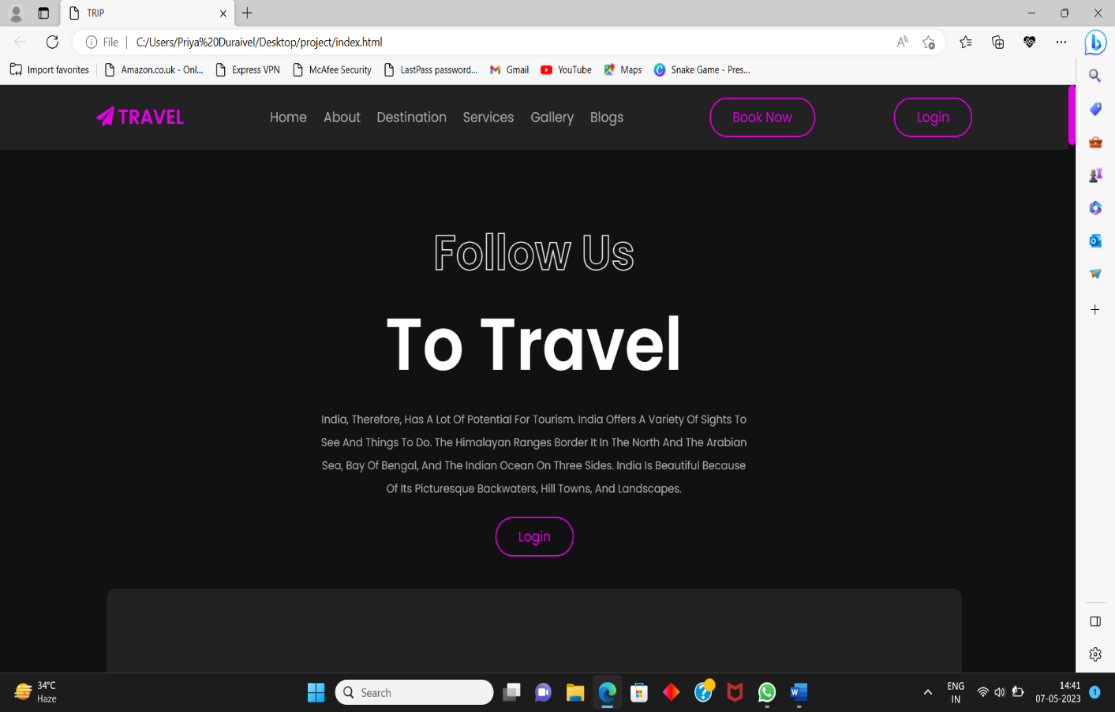

***ABOUT PAGE***

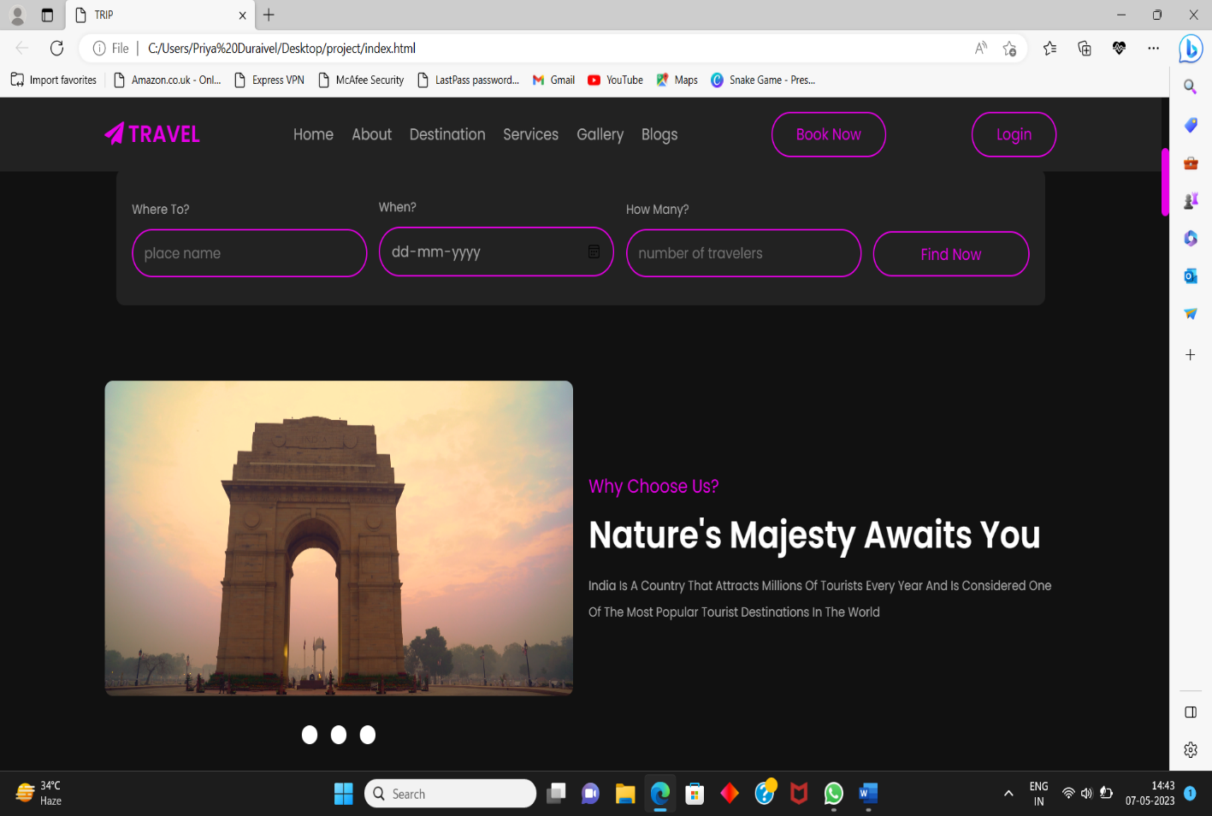

***DESTINATION PAGE***

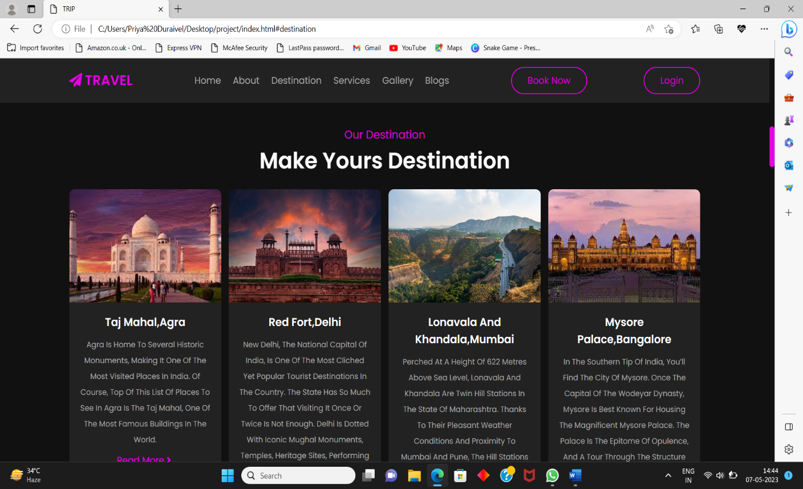

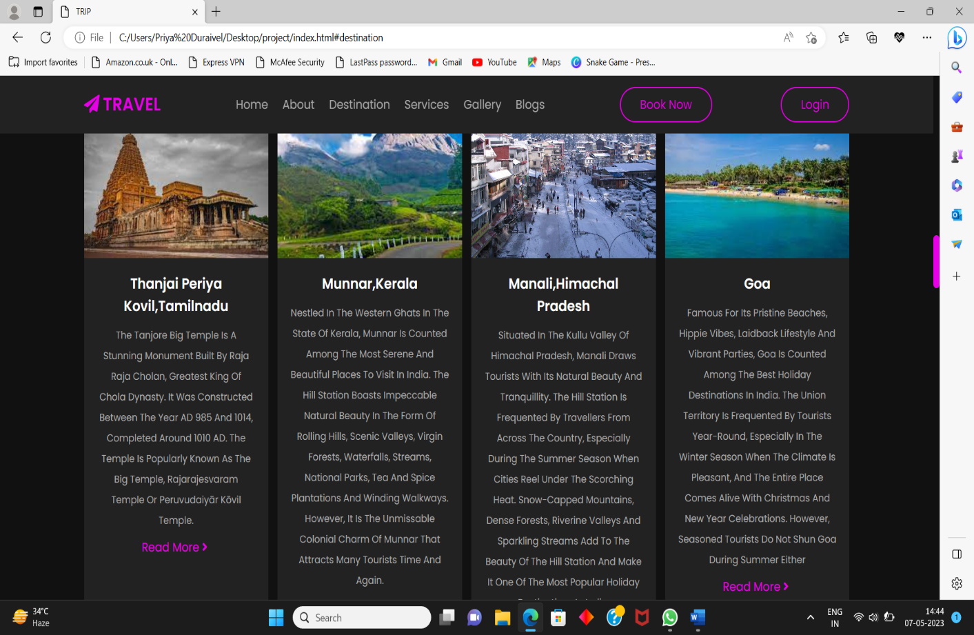

***SERVICES PAGE***

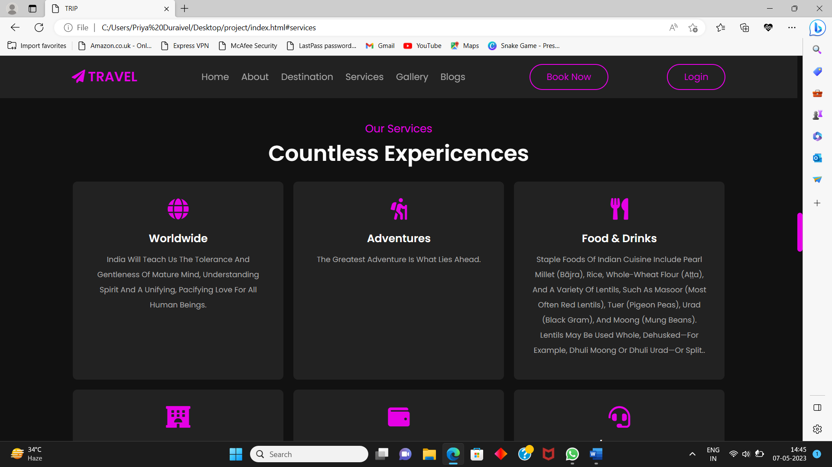

***GALLERY PAGE***

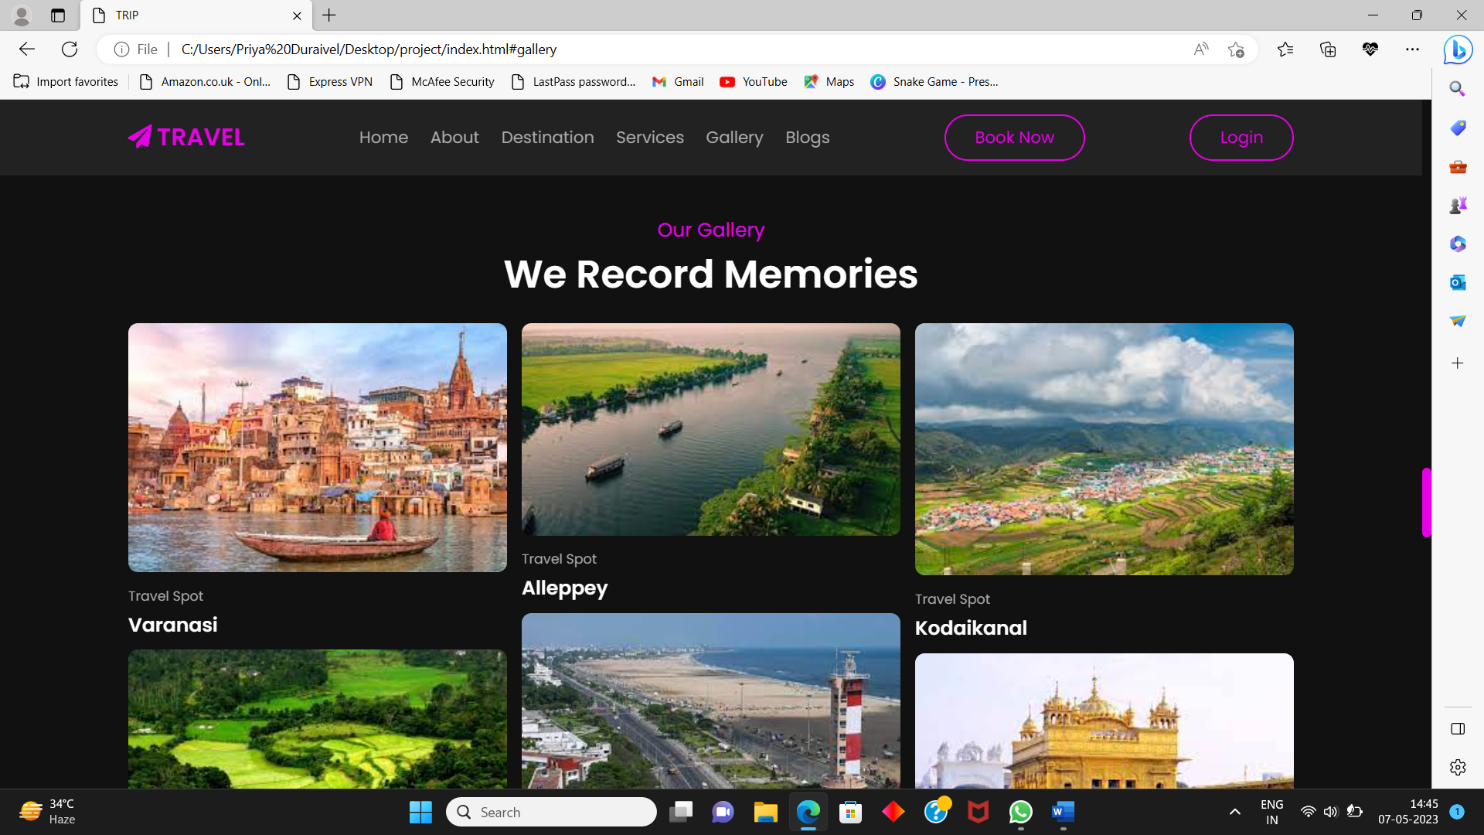

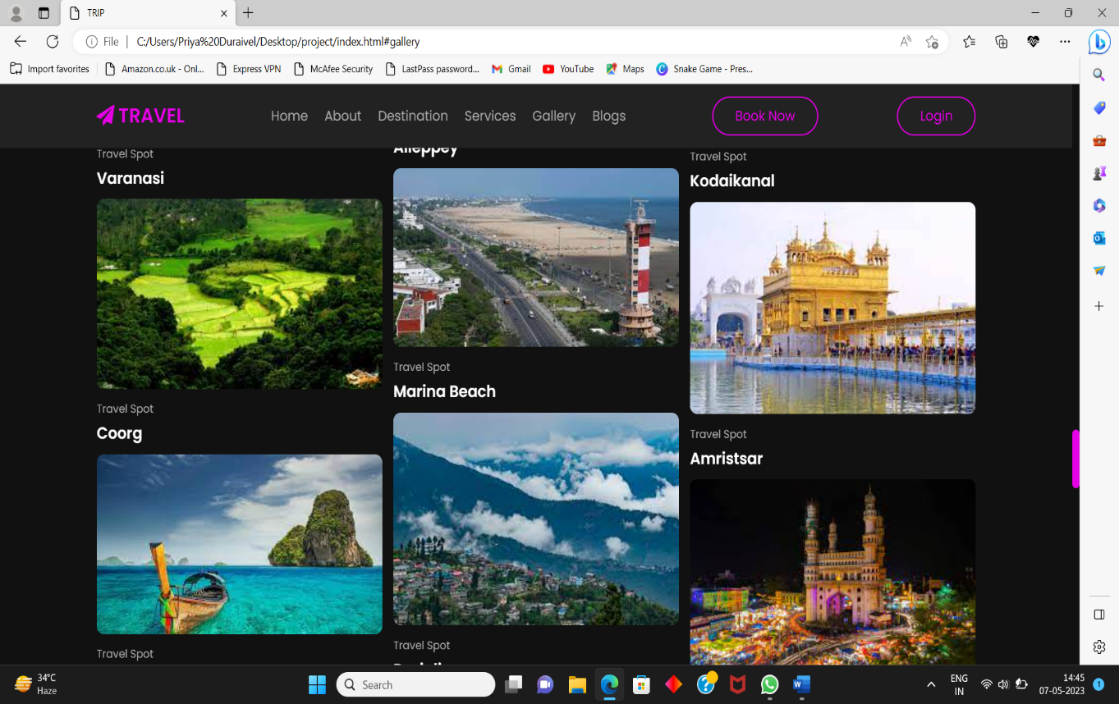

***CLIENTS REVIEW***

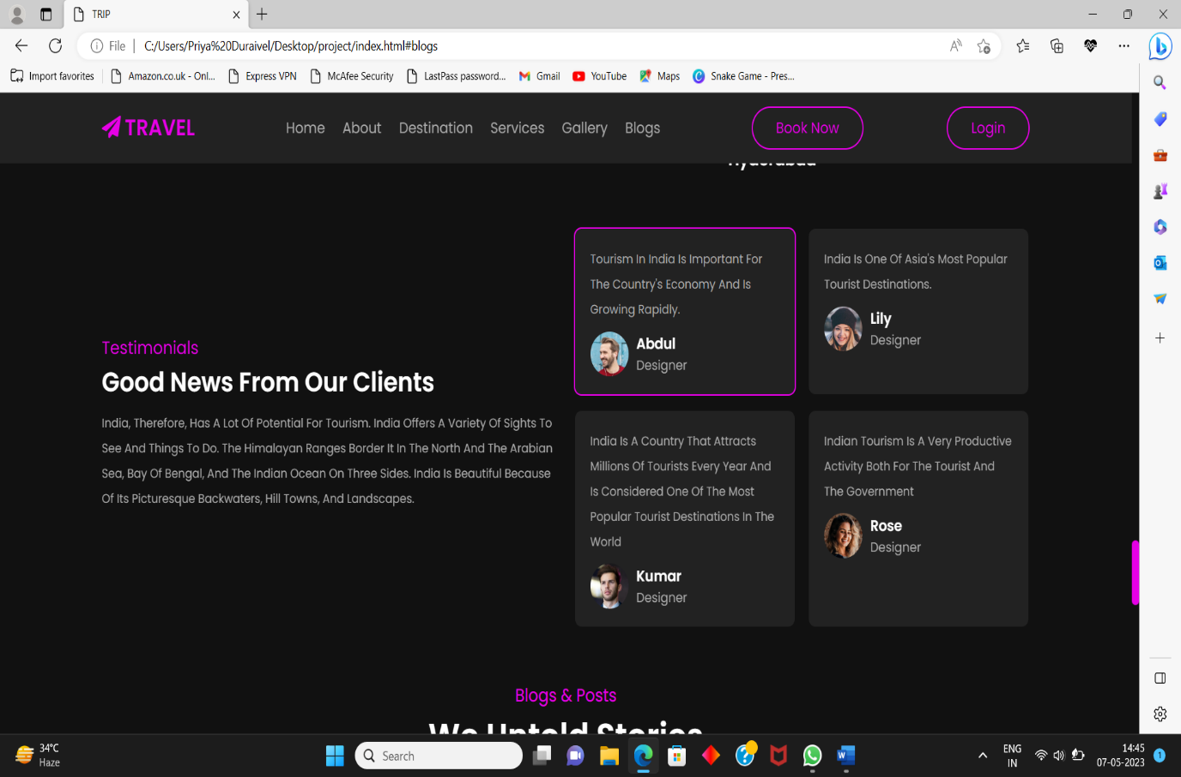

***BLOGS PAGE***

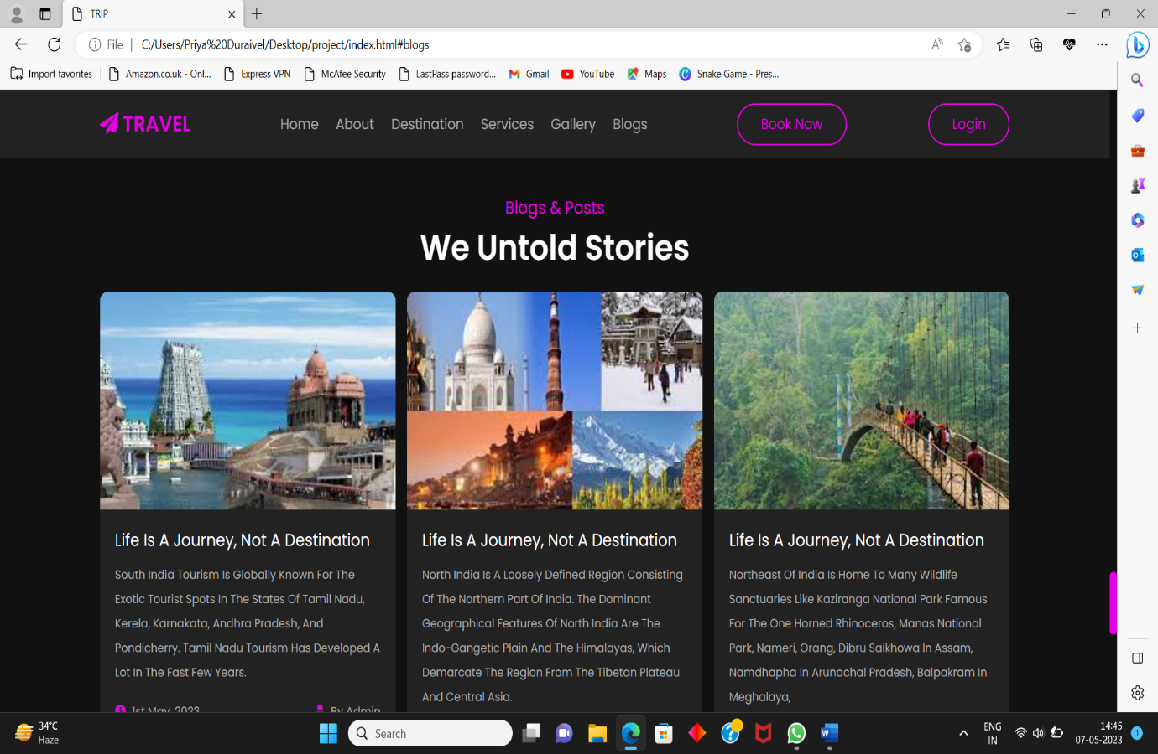

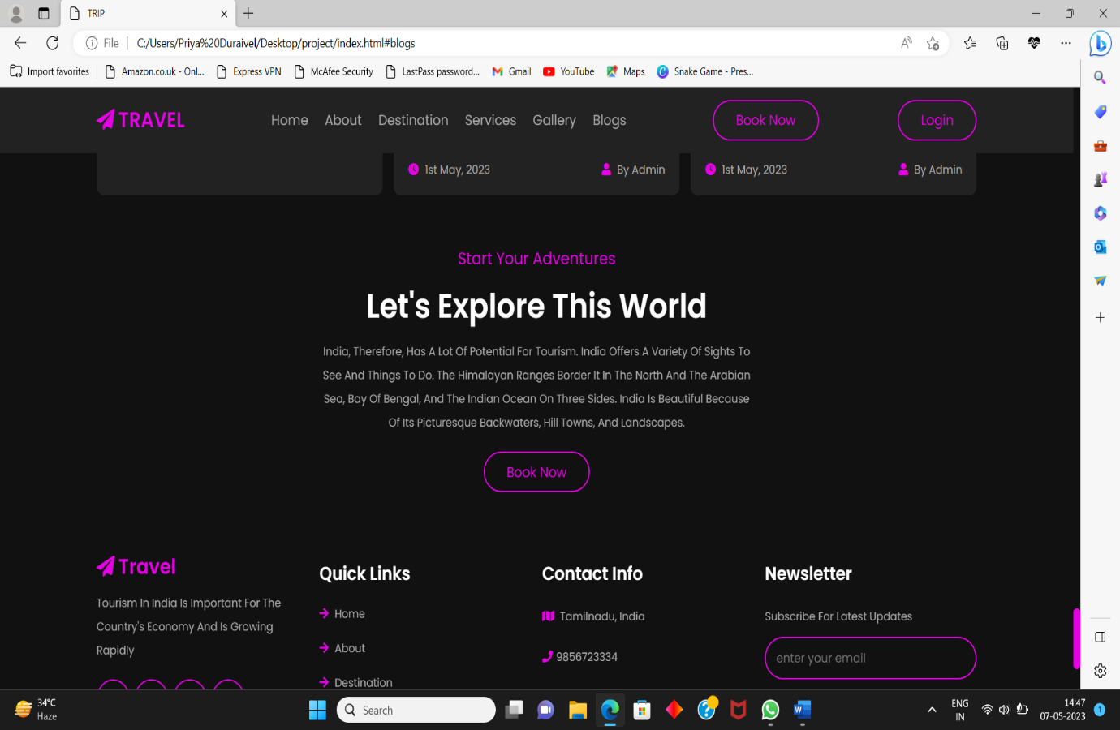

***LOGIN PAGE***

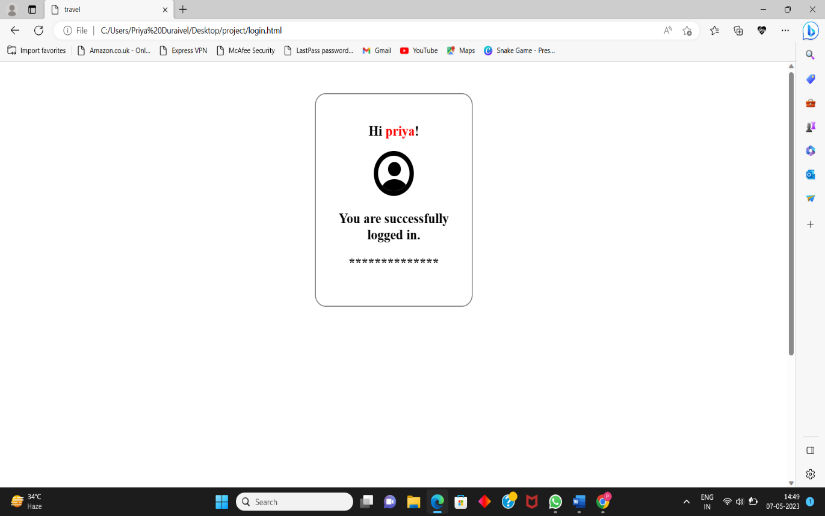

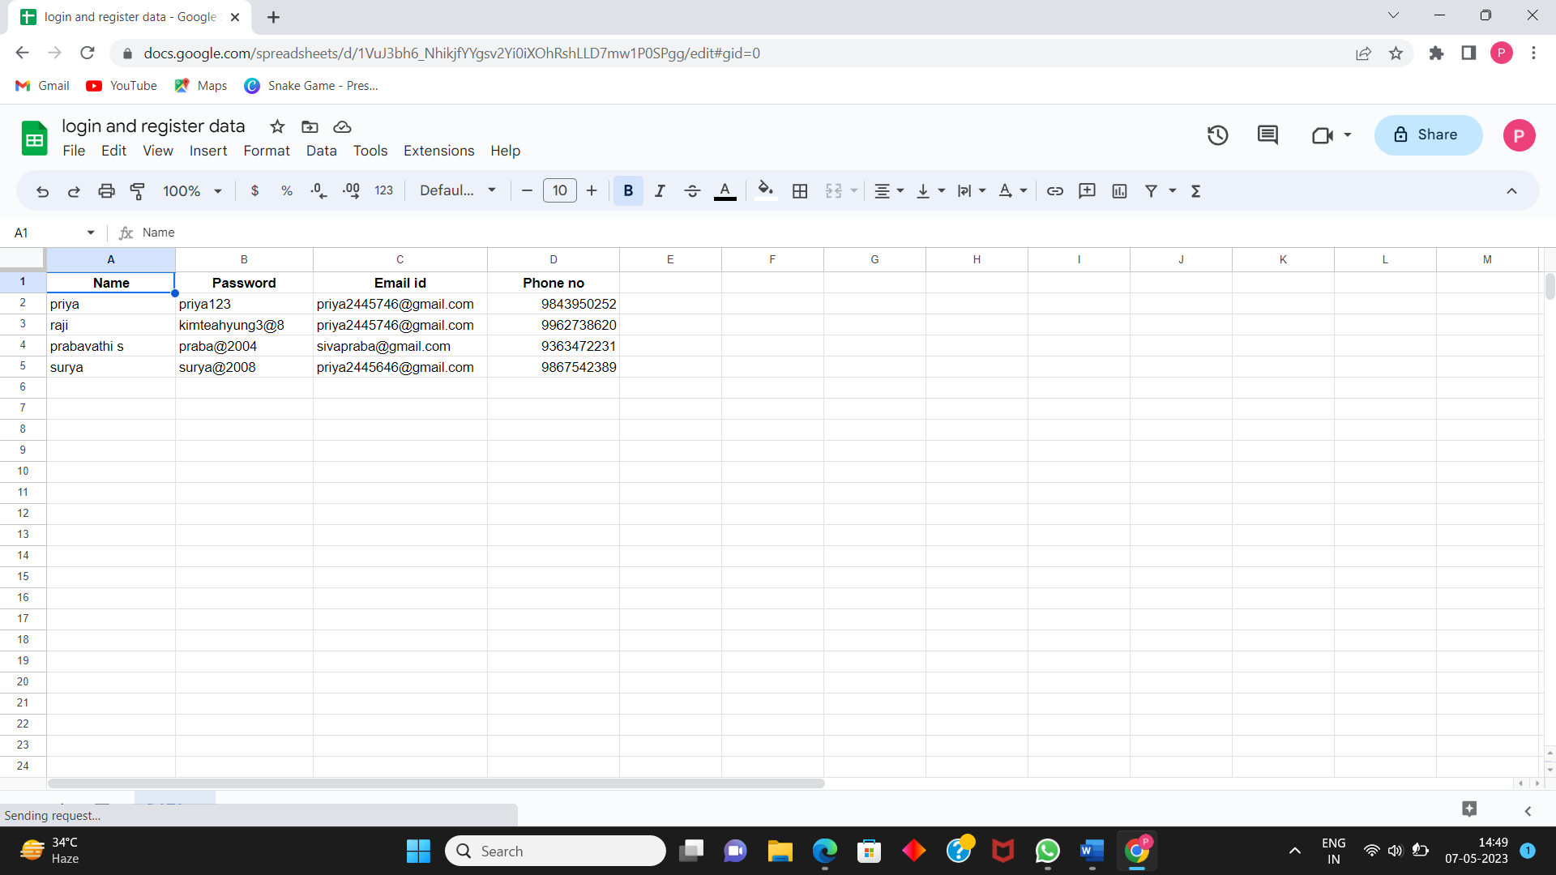

**GITHUB LINK:**

**https://github.com/Priyaduraivel/indiatravel.git**